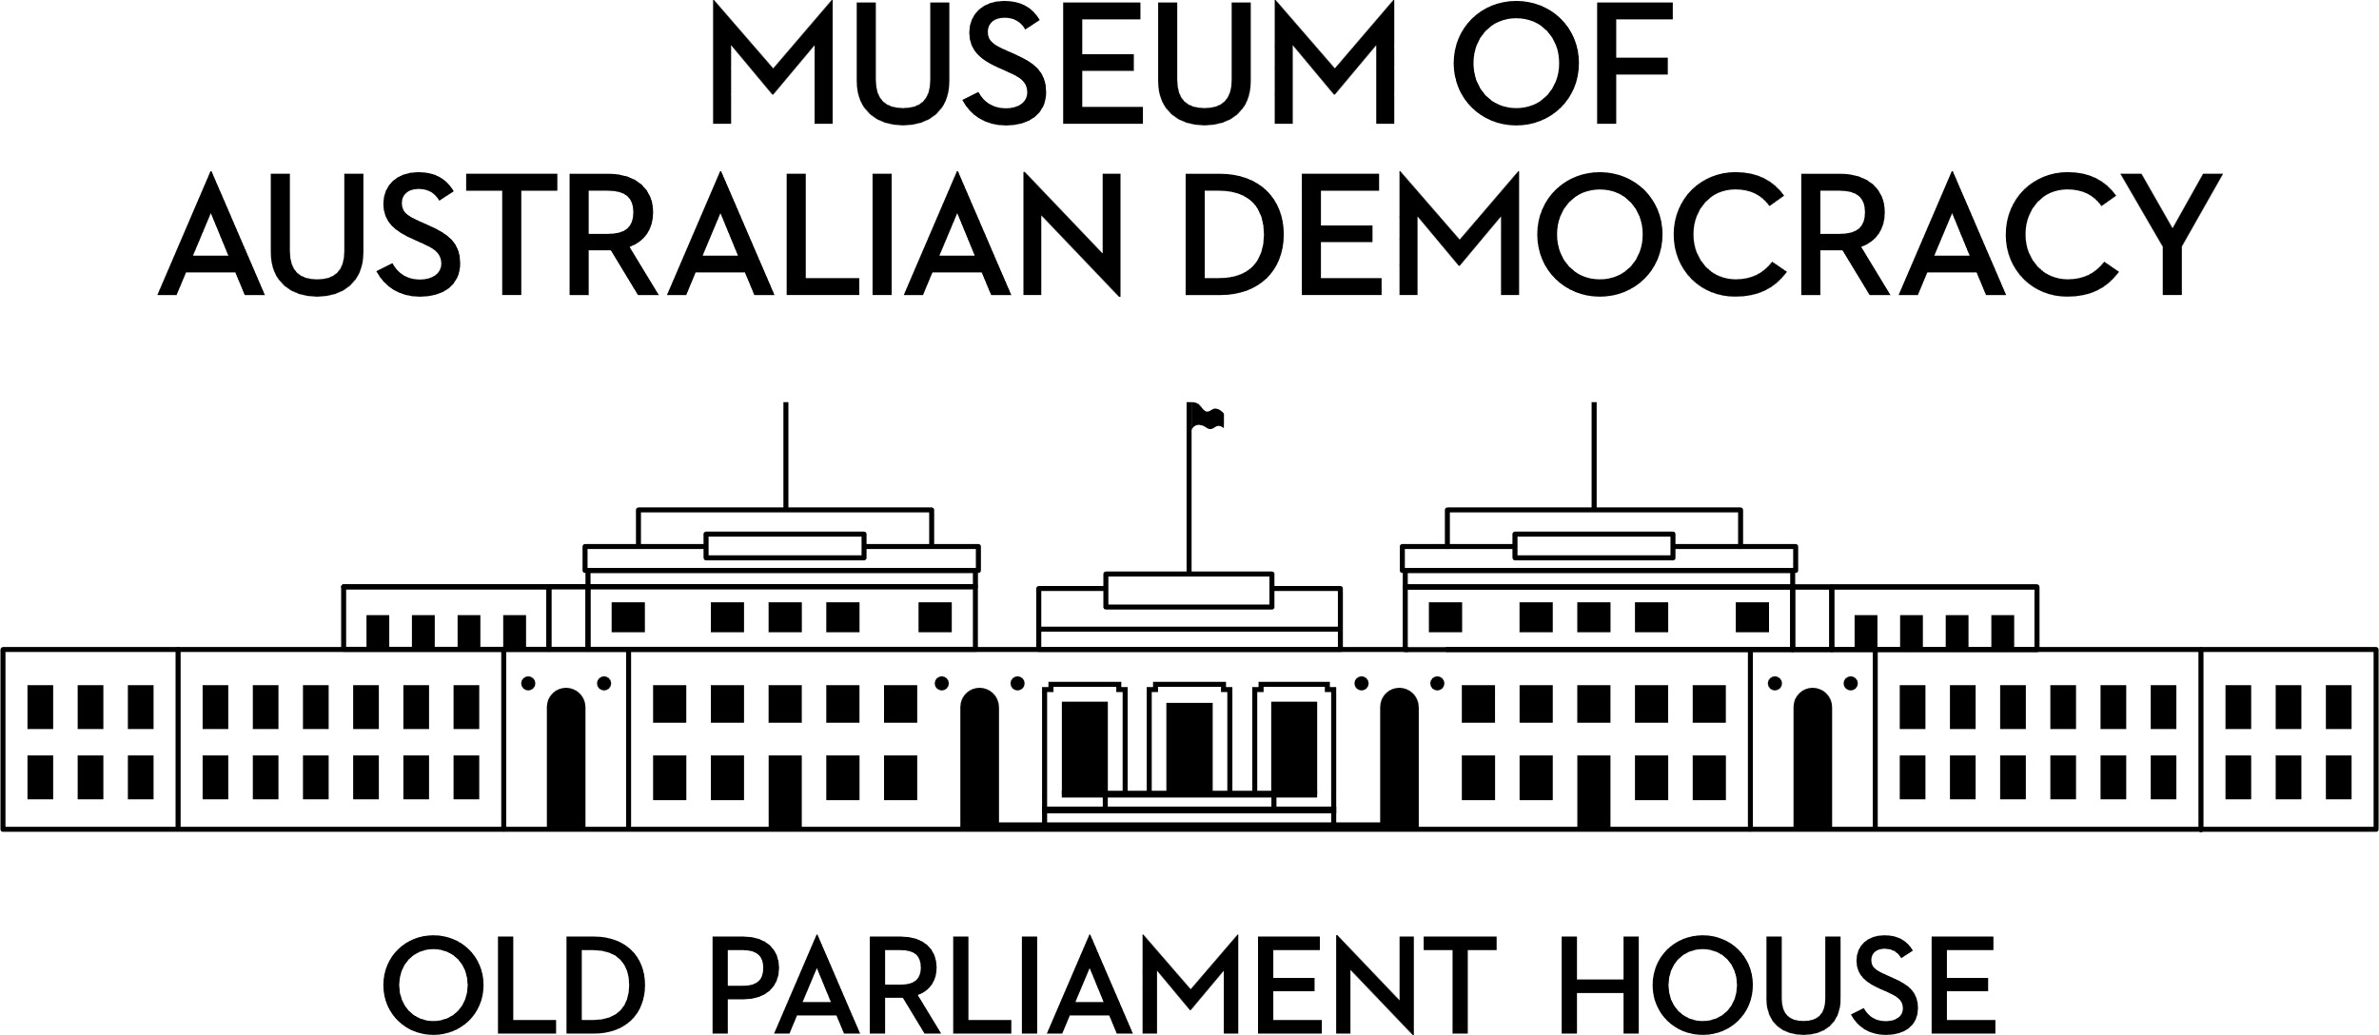

**Client Service Charter**

**Our Purpose**

The Museum of Australian Democracy at Old Parliament House (MoAD) Strategic Plan 2023-2028 will guide how we deliver on our purpose to:

* **protect, conserve and interpret** the national icon that is Old Parliament House to highlight the crucial role the building and its collections have played in shaping today’s Australia
* **share** the story of Australia’s democracy through exhibitions, programs, publications and website content to increase understanding of the nation’s social and political history
* **enable** audiences to actively explore how Australia’s democratic systems work and to be inspired and equipped to participate as engaged citizens in our democracy.

By continuing to deliver our strong suite of public programs, including schools learning programs, and focusing on increasing services and programs for the public, we will foster a museum for the people.

**Our Commitment**

At MoAD we demonstrate our commitment to high quality customer service by providing:

* a welcoming and accessible museum taking into consideration the diverse backgrounds, needs and expectations of all our clients and stakeholders
* communicating with you about what we do and why we do it
* knowledge and learning through our collections, programs and exhibitions
* adherence to heritage management best practice.

**Our Code of Conduct**

We are committed to the Australian Public Service Values and Code of Conduct, and you can expect our staff will:

* behave courteously and with respect
* act with care and diligence
* comply with all applicable Australian laws
* use Commonwealth resources in a proper manner
* provide professional and consistent advice, information and standards of service.

**How to Contact us**

* **telephone** Reception on 02 6270 8222
* **email** us at [info@moadoph.gov.au](mailto:info@moadoph.gov.au)
* **via post** at PO Box 3934 Manuka ACT 2903

**Visitor Feedback Form**

We invite you to provide feedback which will help us to continually strive to improve the visitor experience.

We welcome all enquiries, comments, suggestions or complaints.

______________________________________________________________________________________________________________________________________________________________________________________________________________________________________________________________________________________________________________________________________________________________________________________________________________________________________________________________________________________________________________________________________________________________________________________________________________________________________________________________________________________________________________________________________________________________________________________________________________________________________________________________________________________________________________________________________________________________________________________________________________________________________________________________________________________________________________________________________________________________________________________________________________________________________________________________________________________________________________________________________________________________________________________________________________________________________________________________________________________________________________________________________________________________________________________________________________________

**Thank you for your feedback. Please provide your contact details below if you would like a response.**

Your contact details will be collected, held and used by MoAD for the purposes of contacting you regarding your feedback. See our full privacy statement at <https://www.moadoph.gov.au/privacy>

Name: _____________________________________________________________________

Phone: _____________________________________________________________________

Email and/or postal address: ___________________________________________________

___________________________________________________________________________