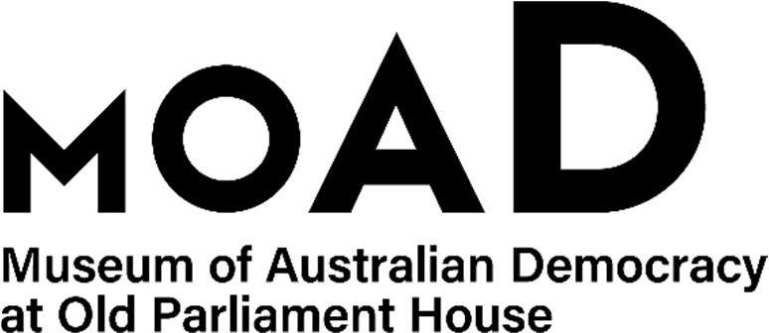

CANDIDATE PACK

|  |  |
| --- | --- |
| **POSITION DETAILS** | |
| **Reference No** | 40011 |
| **Title** | Capital Works Project Manager |
| **Classification** | EL1 |
| **Employment Type** | Ongoing/Non-ongoing |
| **Working Hours** | Full time |
| Salary | Onsite with some work from home considered for the right applicant |
| **Section** | $115,443 - $125,832 plus 15.4% superannuation |
| **Team** | Capital Projects and Built Heritage |
| **Eligibility** | * Australian Citizen * Baseline security clearance (after commencement) |
| **Contact Officer** | Bernard Finucane – 02 6270 8201 |
| **Opening Date** | Monday 17 March 2025 |
| **Closing Date** | Sunday 30 March 2025 (11:59pm) |
| **Special Note** | **This is a non-ongoing opportunity up to December 2026**  Suitable candidates may be placed in a merit pool from this selection process and the pool may be used to fill similar ongoing or non-ongoing roles. Non-ongoing vacancies filled from a merit pool may be offered as a specified term. Applicants may have their application and assessment results shared with other Australian Public Service (APS) agencies looking to fill similar roles. |
| **RecruitAbility** | RecruitAbility applies to this vacancy. Under RecruitAbility you will be invited to participate in further assessment activity for the vacancy if you choose to apply under RecruitAbility; declare you have a disability; and meet the minimum requirements for the position. For more information visit the [APSC website.](https://www.apsc.gov.au/working-aps/diversity-and-inclusion/disability/recruitability) |

**ABOUT US**

The Museum of Australian Democracy (MoAD) at Old Parliament House is located inside a heritage-listed building that was once home to Australia's Parliament (1927 to 1988).

True to our building’s original brief, we provide a ‘people’s place’, where big ideas are explored.

We share the story of Australia's democracy through exhibitions, events and education programs, as well as through our rich online collection of stories, objects and resources.

At MoAD, we celebrate the Australian democratic journey. We seek to provoke thought and inspire conversation by sharing stories and objects that played a part in shaping the nation as it is today.

Careers at MoAD are varied, from human resource officers, exhibition curators, heritage officers and learning facilitators, to digital producers, finance officers and IT specialists. We are a small agency, working in a dynamic environment, sharing our democratic and political history in a heritage-listed building.

MoAD is an inclusive and rewarding workplace that values the contributions of all our staff. We encourage applications from First Nations Australians, people with a disability, culturally and linguistically diverse people and LGBTQIA+ people. We are committed to a safe and supportive workplace which includes flexible working practices.

MoAD employees are engaged under the [*Public Service Act 1999*](https://www.legislation.gov.au/C2004A00538/latest/text) and are subject to the terms and conditions of employment in the [*OPH Enterprise Agreem**ent 2024-2027*](https://moadoph.gov.au/sites/default/files/2024-04/oph-enterprise-agreement-2024-2027.pdf)*.*

# POSITION DETAILS

The position is part of the team responsible for strategic planning and delivery of infrastructure enhancements, with a focus on planning and delivery of major refurbishments, capital works, relations, minor works and other projects.

The successful applicant will be required to deliver project high-quality project outcomes, ensure project approvals are secured in a timely manner, prepare reports and presentations and support the Head of Capital Projects to applying high-level project management expertise to the role and if requested, assist with other capital projects.

**DUTIES**

Reporting to the Head of Capital Projects, the successful applicant will play a key role in the delivering MoAD’s current capital works program.  The position’s role and key responsibilities include:

* Progress, manage and report on all aspects of the project, being the third stage of MoAD’s repair work to hail-damaged roofs, due for practical completion in November 2026
* Manage the external project manager’s deliverables and through them, oversee the sub-consultants’ deliverables, including heritage assessments and approvals
* In conjunction with the external project manager, oversee the contract with the construction company that is delivering the works under a managing contractor contract
* Manage the insurance-related requirements of the project, including liaison with Comcover and the Department of Finance on matters of scope, costs, schedule and reimbursement
* Ensure that the work’s impacts are identified early and that mitigations are planned, agreed and communicated with internal and external stakeholders; and
* Coordinate the works with inter-dependant activities being undertaken across MoAD and with external events that occur within Canberra’s Parliamentary Zone.

**OUR IDEAL CANDIDATE**

Our ideal candidate will demonstrate the following attributes:

* extensive high-level project management experience;
* extensive budget management experience in large and complex projects;
* ability to prepare high quality, accurate and timely documents and reports;
* excellent communication and stakeholder management skills;
* high levels of contract integrity, judgement and initiative;
* strong customer service, team work and collaboration skills;
* experience working in heritage-listed public buildings; and
* proficiency in the use of the MS suite of products, including Project Gantt charts.

**ELIGIBILITY**

To be eligible for employment for this position at MoAD, applicants must:

* Be an Australian Citizen; and
* Have a security clearance or be willing to undertake the process to obtain a baseline clearance (after commencement).
* Hold a current Working with Vulnerable People (WwVP) Card or the ability to obtain one

**YOUR APPLICATION**

Please provide a:

* concise statement of claims of no more than 2 pages. When framing your statement, please ensure you adequately demonstrate your skills, qualifications, experience and capabilities.
* Resume outlining your career history, qualifications and contact details for at least two recent referees (no more than 4 pages).
* coversheet from the [MoAD Website](https://www.moadoph.gov.au/about/careers).
  + MoAD accommodates requests for reasonable adjustment for people with disabilities to participate in an interview, including offering onsite tours to potential employees before their interviews to gauge any possible access barriers and to comfortably see staff spaces before committing to interview or the job position. Please indicate this in your cover sheet or contact the recruitment officer on 02 6270 8192 or 02 6270 8235.

**SUBMISSION OF YOUR APPLICATION**

Your application should be submitted by the closing date to [applications@moadoph.gov.au](mailto:applications@moadoph.gov.au)

For noting:

* Your application will be automatically acknowledged. If you do not receive an automated receipt, please contact 02 6270 8192 or 02 6270 8235 or email [recruitment@moadoph.gov.au](mailto:recruitment@moadoph.gov.au)
* Applications received after closing will not be accepted unless a prior arrangement has been made with the contact officer
* [APSC website](https://www.apsc.gov.au/working-aps/diversity-and-inclusion/disability/recruitability).
* MoAD accommodates requests for reasonable adjustment for people with disabilities to participate in an interview, including offering onsite tours to potential employees before their interviews to gauge any possible access barriers and to comfortably see staff spaces before committing to interview or the job position. Please indicate this in your coversheet or contact the recruitment officer on 02 6270 8192 or 02 6270 8235.