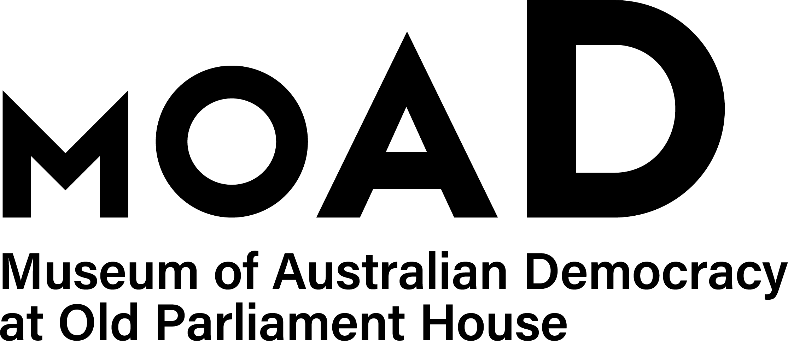
VISITOR & EDUCATION ENGAGEMENT
TEMPORARY EMPLOYMENT REGISTER COVERSHEET
Please complete this form and email it to applications@moadoph.gov.au
along with a copy of your CV.
Please note, you will only be contacted in the event a vacancy arises that match your skills and experience.

PERSONAL DETAILS

Title | Mr Mrs Ms Miss Dr Other__________
Gender | Male Female X - Indeterminate / Unspecified
Surname
Given Names
Address
E-mail address:
Telephone | (m) |  | (w) |  | (h)

TYPE OF WORK PREFERRED (you may select more than one if you wish)

Learning Facilitator
Museum Experience Officer
Museum Engagement Facilitator

ELIGIBILITY

Are you an Australian Citizen | Yes No
Do you have a current security clearance | Yes No
If yes, what level?
Do you have an ACT Working with Vulnerable People Card? | Yes No
Have you received a redundancy benefit from an Australian Public Service (APS) Agency, the Australian Parliamentary Service or the Murray-Darling Basin Commission? | Yes No
If yes, please advise of the redundancy benefit period expire date
Have you ever been found to have breached the APS Code of Conduct? | Yes No
If so, in which organisation?

CURRENT EMPLOYMENT DETAILS

Are you currently employed | Yes No
If you are currently employed in the APS, are you employed | Non-Ongoing Casual
WORKPLACE DIVERSITY

Are you an Aboriginal or Torres Strait Islander | Yes No
Do you have a disability | Yes No
Do you require any special arrangements to be made for assessment eg Interview? | Yes No

