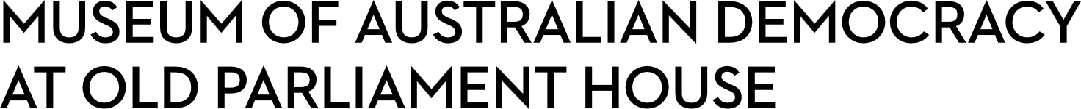
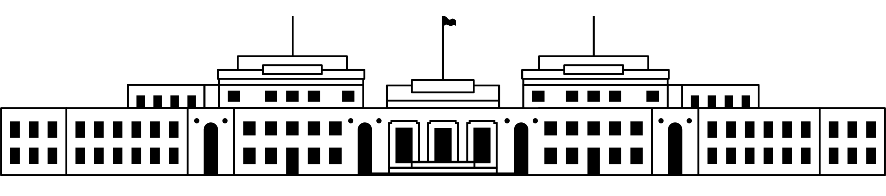

CANDIDATE PACK
POSITION DETAILS
REFERENCE NO | 21100
TITLE | Head, Museum Experience and Learning
CLASSIFICATION | EL2
EMPLOYMENT TYPE | Ongoing
WORKING HOURS | Full-time
OFFICE ARRANGEMENT | On-site
SALARY | $140,697 - $165,302 + 15.4% Superannuation
SECTION | Museum Experience and Learning
TEAM | Museum Experience and Learning
ELIGIBILITY | - Australian Citizenship  - Security Clearance (after commencement)  - Working with Vulnerable People (after commencement)
CONTACT OFFICER | Lee Pluis on 02 6270 8171
OPENING DATE | Friday 28 November 2025
CLOSING DATE | Sunday 14 December 2025 (11:59pm)
SPECIAL NOTE | This is an ongoing opportunity.  Suitable candidates may be placed in a merit pool from this selection process and the pool may be used to fill similar ongoing or non-ongoing roles. Non-ongoing vacancies filled from a merit pool may be offered as a specified term.

ABOUT US
The Museum of Australian Democracy (MoAD) at Old Parliament House is located inside a heritage-listed building that was once home to Australia's Parliament (1927 to 1988).
True to our building’s original brief, we provide a ‘people’s place’, where big ideas are explored.
We share the story of Australia's democracy through exhibitions, events and education programs, as well as through our rich online collection of stories, objects and resources.
At MoAD, we celebrate the Australian democratic journey. We seek to provoke thought and inspire conversation by sharing stories and objects that played a part in shaping the nation as it is today.
Careers at MoAD are varied, from human resource officers, exhibition curators, heritage officers and learning facilitators, to digital producers, finance officers and IT specialists. We are a small agency, working in a dynamic environment, sharing our democratic and political history in a heritage-listed building.
MoAD is an inclusive and rewarding workplace that values the contributions of all our staff. We encourage applications from First Nations Australians, people with a disability, culturally and linguistically diverse people and LGBTQIA+ people. We are committed to a safe and supportive workplace which includes flexible working practices.
MoAD employees are engaged under the Public Service Act 1999 and are subject to the terms and conditions of employment in the OPH Enterprise Agreement 2024-2027.
POSITION DETAILS
The Head, Museum Experience and Learning is a key member of MoAD’s Senior Management Group (SMG), working closely with the Director, Deputy Directors, and Board to deliver MoAD’s vision and the key strategic objectives.

This role provides strategic leadership across the Museum Experience and Learning teams, setting priorities and driving innovation to enhance visitor engagement and learning outcomes.

The position requires extensive experience in shaping strategic direction and leading multidisciplinary teams. It focuses on developing and delivering high quality, vibrant, and inclusive programs that attract diverse audiences and foster community engagement.

You will build and sustain strong external and internal partnerships, working collaboratively and negotiating with stakeholders to achieve shared outcomes.
ROLE RESPONSIBILITIES and DUTIES
- Lead the strategic direction and daily operations of Visitor experiences for the Museum Experience and Learning teams. Ensure effective operations, including administration, resource and financial management as well as staff management and development.

- Oversee the creation and delivery of educational programs that promote MoAD’s democratic mission and are accessible to all Australian classrooms, educators and learners.

- Contribute effectively as a member of the SMG to support the strategic goals of MoAD.

- Develop and foster strong relationships with internal and external stakeholders.

- Prepare high-level written documents, correspondence and reports.

- Build and develop skills and opportunities within the Museum Experience and Learning teams, creating a culture of inclusion and excellence.

OUR IDEAL CANDIDATE

Our ideal candidate will have:

- Extensive experience in leadership roles within cultural institutions, particularly in the context of democratic history, education, or public programs.

- Proven track record of managing and developing large-scale educational and public programs that engage diverse audiences and align with organisational goals.

- In-depth understanding of the Australian democratic system, its history, and the role of civic engagement in fostering a healthy democracy.

- Strong experience in stakeholder management, including negotiation, partnership building, and executing contracts with government, NGOs, and private-sector organisations.

- Demonstrated ability to lead multidisciplinary teams, with a focus on fostering innovation, capacity-building, and continuous professional development.

- Exceptional written and verbal communication skills, with the ability to engage and influence a wide range of internal and external stakeholders.

YOUR APPLICATION

Please provide a:

- concise statement of claims of no more than 2 pages. When framing your statement, please ensure you adequately demonstrate your skills, qualifications, experience and capabilities.

- Resume outlining your career history, qualifications and contact details for at least two recent referees (no more than 4 pages).

- coversheet from the MoAD Website.

MoAD accommodates requests for reasonable adjustment for people with disabilities to participate in an interview, including offering onsite tours to potential employees before their interviews to gauge any possible access barriers and to comfortably see staff spaces before committing to interview or the job position. Please indicate this in your cover sheet or contact the recruitment officer on 02 6270 8235 or 02 6270 8127.

ELIGIBILITY

To be eligible for this position at MoAD, applicants must:
- be an Australian Citizen

- have a security clearance or be willing to undertake the process to obtain a baseline clearance (after commencement)

- have, or be willing to undertake the process to obtain, a Working with Vulnerable People registration

- be willing to provide identity documents and undergo an identity pre-employment check through a Document Verification Service, if you are deemed to be the successful candidate.

SUBMISSION OF APPLICATION
Your application should be submitted by the closing date to applications@moadoph.gov.au

For noting:

- Your application will be automatically acknowledged. If you do not receive an automated receipt, please contact 02 6270 8235 or 02 6270 8127 or email recruitment@moadoph.gov.au

- Applications received after closing will not be accepted unless a prior arrangement has been made with the contact officer

