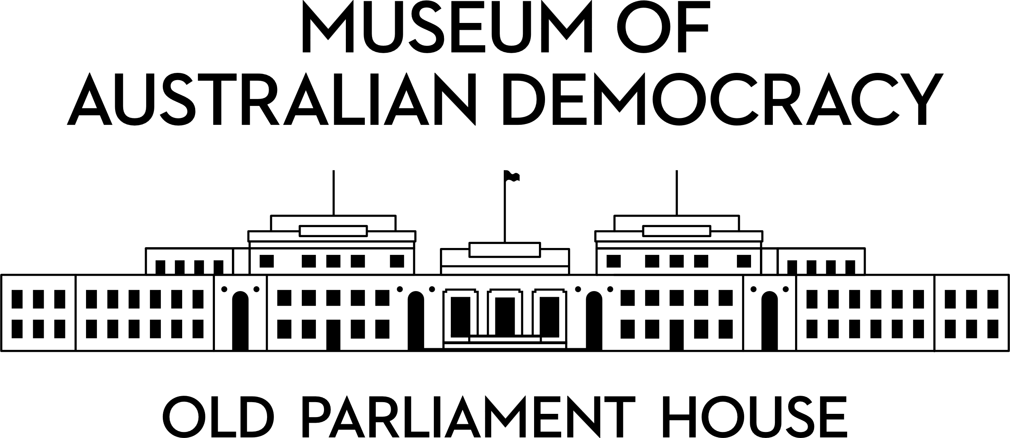

**CANDIDATE PACK**

|  |  |
| --- | --- |
|  | |
| **POSITION DETAILS** | |
| **REFERENCE NO** | 32205 |
| **TITLE** | Salesforce Developer |
| **CLASSIFICATION** | APS Level 5 |
| **EMPLOYMENT TYPE** | Ongoing |
| **WORKING HOURS** | Full-time |
| **OFFICE ARRANGEMENT** | On-site |
| **SALARY** | $84,229 - $91,808 pa + 15.4% Superannuation |
| **SECTION** | IT |
| **TEAM** | IT |
| **ELIGIBILITY** | * Australian Citizenship * Security Clearance (after commencement) |
| **CONTACT OFFICER** | Liam Dovey 02 6270 8204 or [liam.dovey@moadoph.gov.au](mailto:liam.dovey@moadoph.gov.au) |
| **OPENING DATE** | Tuesday, 30/09/2025 |
| **CLOSING DATE** | Monday, 13/10/2025 11:59pm |
| **SPECIAL NOTE** | This is an ongoing opportunity.  Suitable candidates may be placed in a merit pool from this selection process and the pool may be used to fill similar ongoing or non-ongoing roles. Non-ongoing vacancies filled from a merit pool may be offered as a specified term.  Applicants may have their application and assessment results shared with other Australian Public Service (APS) agencies looking to fill similar roles. |

**ABOUT US**

The Museum of Australian Democracy (MoAD) at Old Parliament House is located inside a heritage-listed building that was once home to Australia's Parliament (1927 to 1988).

True to our building’s original brief, we provide a ‘people’s place’, where big ideas are explored.

We share the story of Australia's democracy through exhibitions, events and education programs, as well as through our rich online collection of stories, objects and resources.

At MoAD, we celebrate the Australian democratic journey. We seek to provoke thought and inspire conversation by sharing stories and objects that played a part in shaping the nation as it is today.

Careers at MoAD are varied, from human resource officers, exhibition curators, heritage officers and learning facilitators, to digital producers, finance officers and IT specialists. We are a small agency, working in a dynamic environment, sharing our democratic and political history in a heritage-listed building.

MoAD is an inclusive and rewarding workplace that values the contributions of all our staff. We encourage applications from First Nations Australians, people with a disability, culturally and linguistically diverse people and LGBTQIA+ people. We are committed to a safe and supportive workplace which includes flexible working practices.

MoAD employees are engaged under the [*Public Service Act 1999*](https://www.legislation.gov.au/C2004A00538/latest/text) and are subject to the terms and conditions of employment in the [*OPH Enterprise Agreem**ent 2024-2027*](https://moadoph.gov.au/sites/default/files/2024-04/oph-enterprise-agreement-2024-2027.pdf)*.*

**POSITION DETAILS**

As a Salesforce Developer, you will be part of the team responsible for the ongoing development and enhancement of our Salesforce platform, supporting both business-as-usual operations and development of new projects. You will provide technical support through our helpdesk ticketing system, ensuring timely resolution of issues and maintaining a high standard of service. A key part of your role will involve maintaining and constructing development pipelines, as well as contributing to the design and implementation of automated testing infrastructure to support quality assurance.

You will also be expected to produce clear and comprehensive technical documentation for the systems you develop and actively participate in the technical planning of new features and projects. The role requires strong task management skills within a shared DevOps environment, and familiarity with tools such as Git, Salesforce CLI, and Azure for repository and release management.

A solid understanding of relational databases and secure system design is essential. You should be proficient in Salesforce technologies including Apex, Lightning Web Components, Flows, and general administrative configuration. This is a hands-on technical role suited to someone who enjoys solving complex problems and contributing to a collaborative IT team.

**ROLE RESPONSIBILITIES and DUTIES**

Under the direction of the Senior Salesforce Developer the Salesforce Developer will be required to:

• Develop and maintain MoAD’s Salesforce platform across Business-As-Usual (BAU) and new projects.

• Provide technical support for Salesforce through a ticketing/helpdesk system.

• Contribute to maintenance and construction data pipelines to support system operations.

• Design and implement automated testing infrastructure for technical validation.

• Create and maintain technical documentation for developed systems and features.

• Contribute to technical planning and architecture of projects and new functionalities.

**OUR IDEAL CANDIDATE**

To be successful for this role you will need to demonstrate:

* Demonstrated ability to think strategically and operationally to support current and future workforce needs.
* Ability to work independently within a changing environment, balancing multiple priorities with a high degree of accountability.
* Demonstrated ability to show initiative, share knowledge, take on constructive feedback and take responsibility for personal development.
* Ability to manage personal tasks effectively within a shared DevOps environment.
* Experience with DevOps systems for repository management and structured release processes using:
  + Git
  + Salesforce CLI
  + Azure DevOps
* Familiarity with relational databases and security-conscious design principles.
* Strong Salesforce development skills, including:
  + Apex programming
  + Lightning Web Components (LWC)
  + Flow automation
  + Administrative configuration and maintenance

**YOUR APPLICATION**

Please provide a:

* concise statement of claims of no more than 2 pages. When framing your statement, please ensure you adequately demonstrate your skills, qualifications, experience and capabilities.
* Resume outlining your career history, qualifications and contact details for at least two recent referees (no more than 4 pages).
* coversheet from the [MoAD Website](https://www.moadoph.gov.au/about/careers).

MoAD accommodates requests for reasonable adjustment for people with disabilities to participate in an interview, including offering onsite tours to potential employees before their interviews to gauge any possible access barriers and to comfortably see staff spaces before committing to interview or the job position. Please indicate this in your cover sheet or contact the recruitment officer on 02 6270 8235 or 02 6270 8127.

**ELIGIBILITY**

To be eligible for this position at MoAD, applicants must:

* be an Australian Citizen; and
* have a security clearance or be willing to undertake the process to obtain a baseline clearance (after commencement).
* be willing to provide identity documents and undergo an identity pre-employment check through a Document Verification Service, if you are deemed to be the successful candidate.

**SUBMISSION OF APPLICATION**

Your application should be submitted by the closing date to [applications@moadoph.gov.au](mailto:applications@moadoph.gov.au)

For noting:

* Your application will be automatically acknowledged. If you do not receive an automated receipt, please contact 02 6270 8235 or 02 6270 8127 or email [recruitment@moadoph.gov.au](mailto:recruitment@moadoph.gov.au)
* Applications received after closing will not be accepted unless a prior arrangement has been made with the contact officer