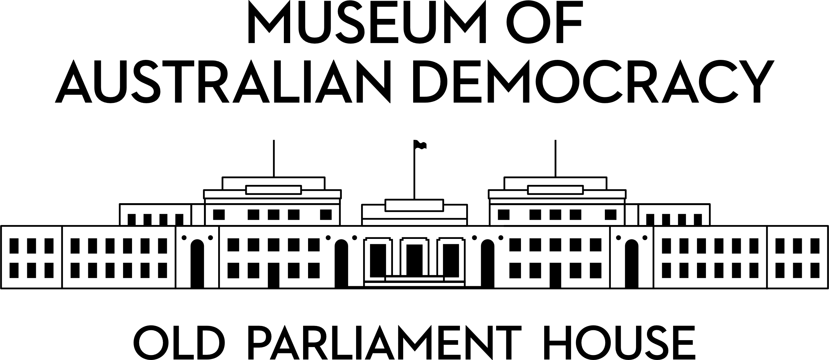

**CANDIDATE PACK**

|  |  |
| --- | --- |
| **POSITION DETAILS** | |
| **REFERENCE NO** | 35111 |
| **TITLE** | Budget Officer |
| **CLASSIFICATION** | APS Level 5 |
| **EMPLOYMENT TYPE** | Ongoing |
| **WORKING HOURS** | Full-time |
| **OFFICE ARRANGEMENT** | Hybrid with work from home considered |
| **SALARY** | $84,229 to $91,808 pa plus 15.4% superannuation |
| **SECTION** | Finance and HR |
| **TEAM** | Finance |
| **ELIGIBILITY** | * Australian Citizenship * Security Clearance (after commencement) |
| **CONTACT OFFICER** | Peter Gilmore (02) 6270 8126 |
| **OPENING DATE** | Wednesday 1 October 2025 |
| **CLOSING DATE** | Wednesday 15 October 2025 (11:59pm) |
| **SPECIAL NOTE** | This is an ongoing opportunity.  Suitable candidates may be placed in a merit pool from this selection process and the pool may be used to fill similar ongoing or non-ongoing roles. Non-ongoing vacancies filled from a merit pool may be offered as a specified term.  Applicants may have their application and assessment results shared with other Australian Public Service (APS) agencies looking to fill similar roles. |

# ABOUT US

The Museum of Australian Democracy (MoAD) at Old Parliament House is located inside a heritage- listed building that was once home to Australia's Parliament (1927 to 1988).

True to our building’s original brief, we provide a ‘people’s place’, where big ideas are explored.

We share the story of Australia's democracy through exhibitions, events and education programs, as well as through our rich online collection of stories, objects and resources.

At MoAD, we celebrate the Australian democratic journey. We seek to provoke thought and inspire conversation by sharing stories and objects that played a part in shaping the nation as it is today.

Careers at MoAD are varied, from human resource officers, exhibition curators, heritage officers and learning facilitators, to digital producers, finance officers and IT specialists. We are a small agency, working in a dynamic environment, sharing our democratic and political history in a heritage-listed building.

MoAD is an inclusive and rewarding workplace that values the contributions of all our staff. We encourage applications from First Nations Australians, people with a disability, culturally and linguistically diverse people and LGBTQIA+ people. We are committed to a safe and supportive workplace which includes flexible working practices.

MoAD employees are engaged under the [*Public Service Act 1999*](https://www.legislation.gov.au/C2004A00538/latest/text)and are subject to the terms and conditions of employment in the [*OPH Enterprise Agreement 2024-2027*](https://moadoph.gov.au/sites/default/files/2024-04/oph-enterprise-agreement-2024-2027.pdf)*.*

# POSITION DETAILS

The Finance team is committed to providing excellent client focused services to MoAD staff and is responsible for the financial management of MoAD, including:

* Financial operations such as accounts payable and receivable, treasury and cash management.
* Internal budgeting for both operational and capital budgets and providing financial advice to internal stakeholders.
* Asset management across a long-term lifecycle.
* Provision of high-quality financial reporting for internal and external stakeholders.
* Financial statement preparation and related month and year-end processes.
* Maintaining MoAD’s internal financial control environment and related administrative procedures.
* Financial Policy including financial delegations and Accountable Authority Instructions (AAI’s).
* External Budget management including maintaining MoAD’s entries into the Government’s Central Budget Management System (CBMS).

The Budget Officer is an integral part of the Finance Team and focuses primarily on internal budgeting and project accounting. The Budget Officer will work closely with the Finance Manager and the CFO to ensure MoAD’s budgets are appropriately prepared and monitored, and that the reporting to stakeholders is comprehensive and fit for purpose by contributing tailored variance commentary.

# ROLE RESPONSIBILITIES and DUTIES

Under limited supervision, the Budget Officer will be required to:

* Assist with the development of the annual internal operating budget and perform the mid-year budget review, including staffing, supplier, revenue and operational projects.
* Maintain the long-term capital project budgets.
* Meet with business areas and project managers to discuss their performance against budgets.
* Update MoAD’s financial forecast throughout the year to inform the CFO of expected results.
* Perform financial analysis to inform variance commentary for reporting to the executive, Audit, Risk and Finance Committee and the Board.
* Provide financial advice and ad-hoc financial analysis to business areas and project managers.
* Other finance functions as advised.

# OUR IDEAL CANDIDATE

To be successful for this role you will need to demonstrate:

* Experience in accounting and reporting functions as outlined in the position’s role responsibilities and duties.
* Well-developed communication (written and oral), presentation and interpersonal skills.
* Ability to prioritise competing tasks, establish clear work plans and timeframes.
* Ability to work independently and as part of a team within a changing environment, balancing multiple priorities with a high degree of accountability.
* Demonstrated ability to show initiative, share knowledge, take on constructive feedback and take responsibility for personal development.
* Advanced proficiency in the use of Microsoft Excel, financial management information systems such as MYOB, SAP, Tech One.
* Ability and willingness to learn new systems essential.
* Tertiary qualifications in Accounting, Commerce, Finance or a related field are desirable, as is  
  progress toward CA / CPA professional membership.

# YOUR APPLICATION

Please provide a:

* + concise statement of claims of no more than 2 pages. When framing your statement, please ensure you adequately demonstrate your skills, qualifications, experience and capabilities.
  + Resume outlining your career history, qualifications and contact details for at least two recent referees (no more than 4 pages).
  + coversheet from the [MoAD Website](https://www.moadoph.gov.au/about/careers).

MoAD accommodates requests for reasonable adjustment for people with disabilities to participate in an interview, including offering onsite tours to potential employees before their interviews to gauge any possible access barriers and to comfortably see staff spaces before committing to interview or the job position. Please indicate this in your cover sheet or contact the recruitment officer on 02 6270 8235

or 02 6270 8127.

# ELIGIBILITY

To be eligible for this position at MoAD, applicants must:

* + be an Australian Citizen; and
  + have a security clearance or be willing to undertake the process to obtain a baseline clearance (after commencement); and
  + be willing to provide identity documents and undergo an identity pre-employment check through a Document Verification Service, if you are deemed to be the successful candidate.

# SUBMISSION OF APPLICATION

Your application should be submitted by the closing date to [applications@moadoph.gov.au](mailto:applications@moadoph.gov.au)

For noting:

* + Your application will be automatically acknowledged. If you do not receive an automated receipt, please contact 02 6270 8235 or 02 6270 8127 or email [recruitment@moadoph.gov.au](mailto:recruitment@moadoph.gov.au)
  + Applications received after closing will not be accepted unless a prior arrangement has been made with the contact officer.