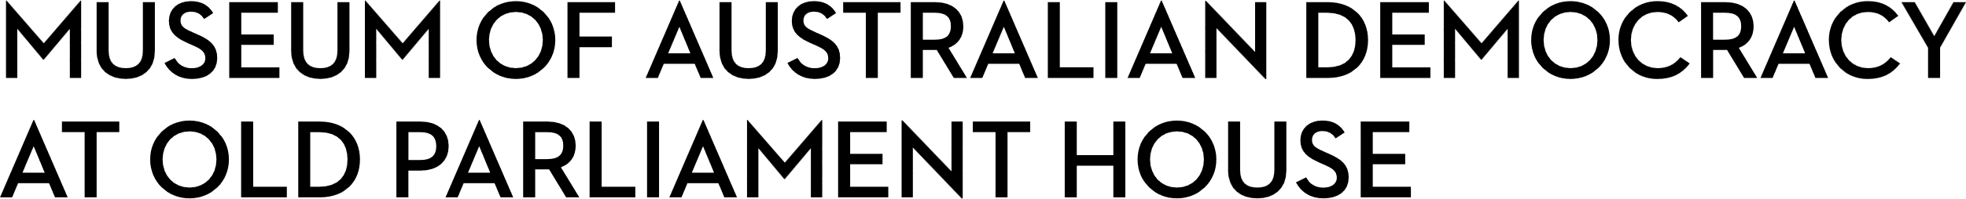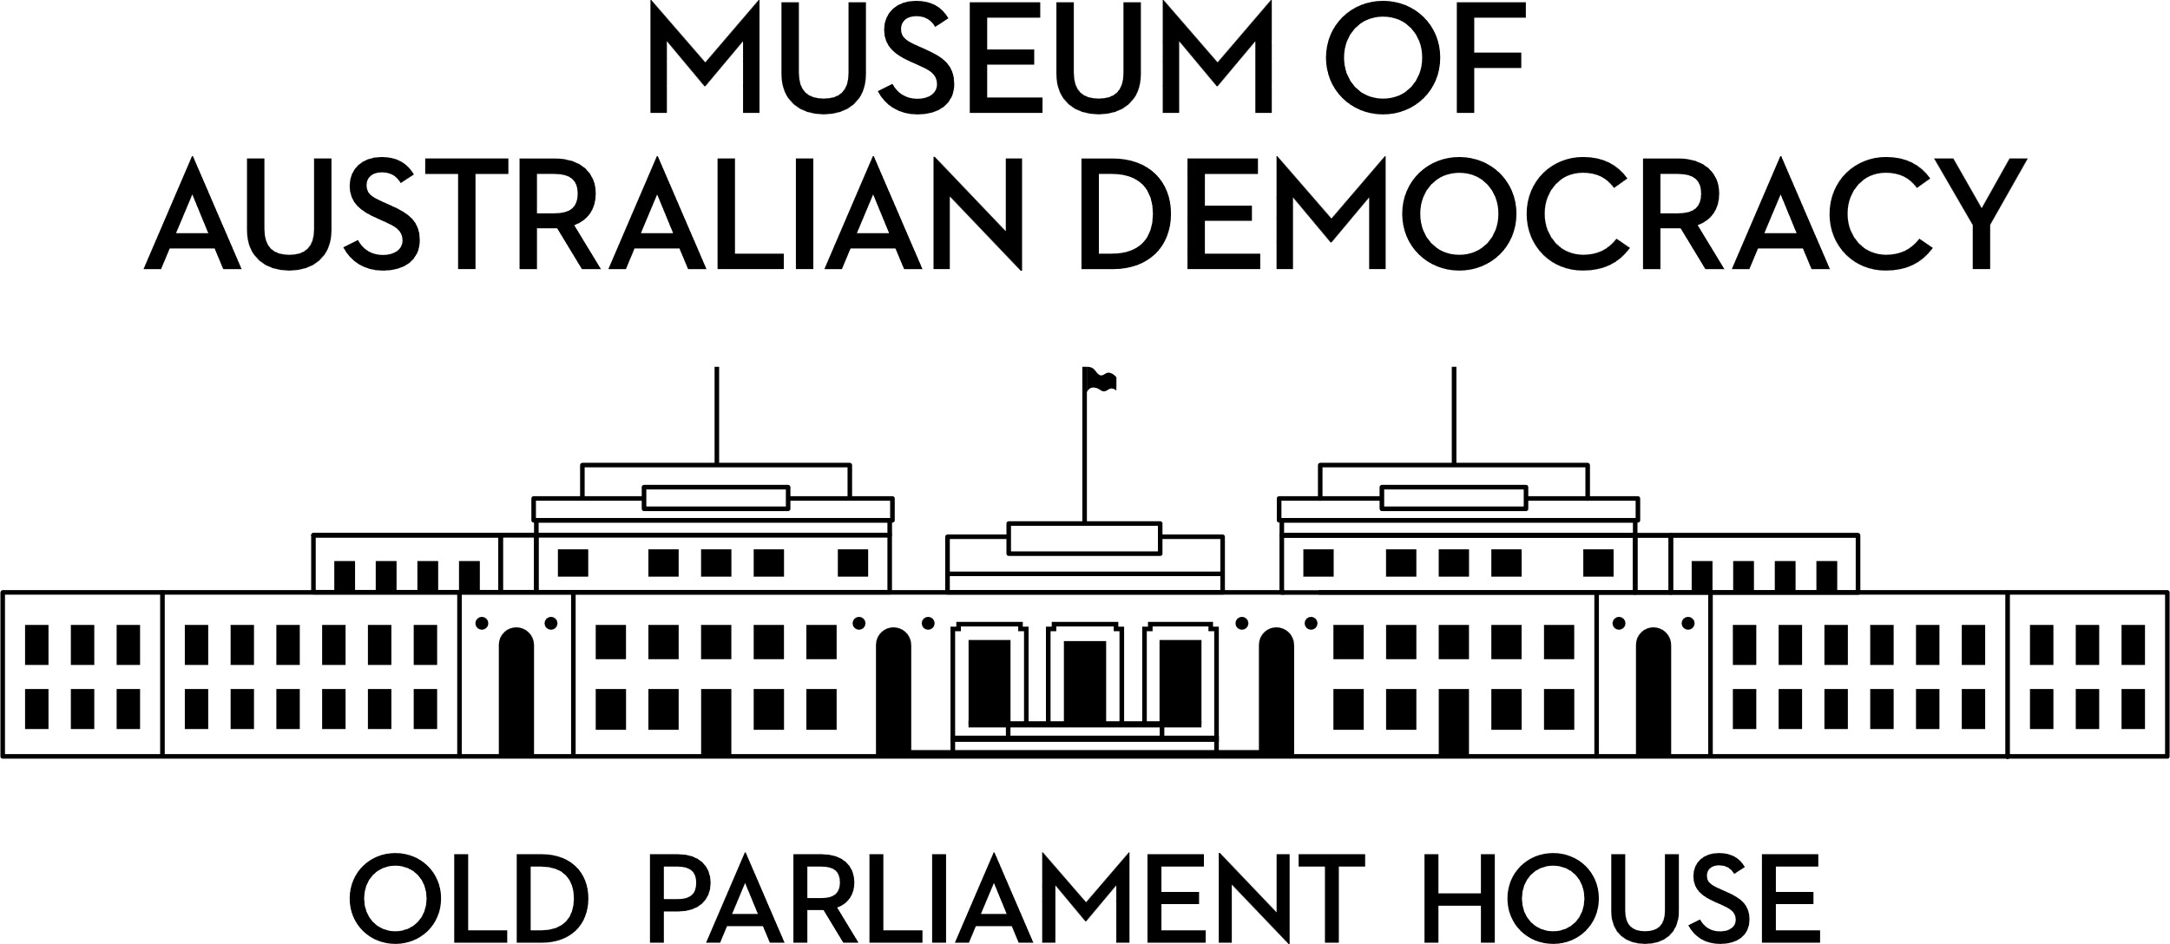

**CANDIDATE PACK**

|  |  |
| --- | --- |
|  | |
| **POSITION DETAILS** | |
| **REFERENCE NO** | 21106 |
| **TITLE** | Learning Supervisor |
| **CLASSIFICATION** | APS5 |
| **EMPLOYMENT TYPE** | 12 months non-ongoing, possibility of extension or ongoing |
| **WORKING HOURS** | Full-time |
| **OFFICE ARRANGEMENT** | On-site |
| **SALARY** | $84,229 - $91,808 pa + 15.4% Superannuation |
| **SECTION** | Museum Experience and Learning |
| **TEAM** | Learning |
| **ELIGIBILITY** | * Australian Citizenship * Security Clearance (after commencement) * Working with Vulnerable People registration |
| **CONTACT OFFICER** | Meg Shakeshaft, Megan.Shakeshaft@moadoph.gov.au |
| **OPENING DATE** | Friday 14 August 2025 |
| **CLOSING DATE** | Monday 1 September 11.59pm |
| **SPECIAL NOTE** | **This is a non-ongoing opportunity for 12 months, with the possibility of extension or ongoing.**  Suitable candidates may be placed in a merit pool from this selection process and the pool may be used to fill similar ongoing or non-ongoing roles. Non-ongoing vacancies filled from a merit pool may be offered as a specified term.  Applicants may have their application and assessment results shared with other Australian Public Service (APS) agencies looking to fill similar roles. |

**ABOUT US**

The Museum of Australian Democracy (MoAD) at Old Parliament House is located inside a heritage-listed building that was once home to Australia's Parliament (1927 to 1988).

True to our building’s original brief, we provide a ‘people’s place’, where big ideas are explored.

We share the story of Australia's democracy through exhibitions, events and education programs, as well as through our rich online collection of stories, objects and resources.

At MoAD, we celebrate the Australian democratic journey. We seek to provoke thought and inspire conversation by sharing stories and objects that played a part in shaping the nation as it is today.

Careers at MoAD are varied, from human resource officers, exhibition curators, heritage officers and learning facilitators, to digital producers, finance officers and IT specialists. We are a small agency, working in a dynamic environment, sharing our democratic and political history in a heritage-listed building.

MoAD is an inclusive and rewarding workplace that values the contributions of all our staff. We encourage applications from First Nations Australians, people with a disability, culturally and linguistically diverse people and LGBTQIA+ people. We are committed to a safe and supportive workplace which includes flexible working practices.

MoAD employees are engaged under the [*Public Service Act 1999*](https://www.legislation.gov.au/C2004A00538/latest/text) and are subject to the terms and conditions of employment in the [*OPH Enterprise Agreem**ent 2024-2027*](https://moadoph.gov.au/sites/default/files/2024-04/oph-enterprise-agreement-2024-2027.pdf)*.*

**POSITION DETAILS**

The Learning Supervisor position plays a key role in the support of development and delivery of highly successful onsite, online and outreach learning programs by a high performing team of presenters in a heritage building.  
  
This position also requires supporting professional development opportunities for teachers, tertiary students, and museum colleagues; and working closely with other teams across the Museum.

**ROLE RESPONSIBILITIES and DUTIES**

Under the direction of the Manager Learning – Onsite and Outreach, the Learning Supervisor will be required to:

* Support the design, development, delivery, and evaluation of high quality, innovative learning programs and resources for school students and teachers visiting the museum onsite, online, and virtually. Programs must align with the Australian Curriculum and MoAD’s Learning Philosophy.
* Provide leadership as team supervisor for daily operations and administration including program delivery, digital technology, surveys, PACER, rostering, statistics, and reports.
* Deliver and model best practice learning programs using a variety of engagement techniques and education pedagogy for all ages and abilities in a variety of contexts, including digital excursions.
* Work collaboratively with Learning Coordinators to support the delivery of digital excursions and professional development/mentoring of staff, including project work supervision.
* Present and participate in professional learning in a variety of formats – conferences, workshops, and webinars; contribute to Learning’s social media accounts.
* Work collaboratively with other teams across the museum, within the broader museum sector and with critical external stakeholder groups including teachers, tour operators and school communities.

**OUR IDEAL CANDIDATE**

To be successful for this role you will need to demonstrate:

* Demonstrated experience in developing, delivering and evaluating education/learning programs, including digital.
* Demonstrated ability to manage competing priorities, develop rosters, supervise staff and manage workflows in fast-paced environment.
* Self-motivated with strong communication and interpersonal skills, solid project management and willingness to learn new skills, including digital technologies.
* Demonstrated experience in liaising with internal and external stakeholders to promote and enrich cross team initiatives and the civics and citizenship learning role of the Museum.
* Demonstrated knowledge and capacity to apply Work Health and Safety within a work and team environment that delivers learning programs in a heritage site.
* Tertiary qualifications in Education/Australian History/Political Sciences/Media Arts would be desirable.

**YOUR APPLICATION**

Please provide a:

* concise statement of claims of no more than 2 pages. When framing your statement, please ensure you adequately demonstrate your skills, qualifications, experience and capabilities.
* Resume outlining your career history, qualifications and contact details for at least two recent referees (no more than 4 pages).
* coversheet from the [MoAD Website](https://www.moadoph.gov.au/about/careers).

MoAD accommodates requests for reasonable adjustment for people with disabilities to participate in an interview, including offering onsite tours to potential employees before their interviews to gauge any possible access barriers and to comfortably see staff spaces before committing to interview or the job position. Please indicate this in your cover sheet or contact the recruitment officer on 02 6270 8235 or 02 6270 8127.

**ELIGIBILITY**

To be eligible for this position at MoAD, applicants must:

* be an Australian Citizen; and
* Obtain a Working with Vulnerable People card prior to commencement; and
* have a security clearance or be willing to undertake the process to obtain a baseline clearance (after commencement).
* be willing to provide identity documents and undergo an identity pre-employment check through a Document Verification Service, if you are deemed to be the successful candidate.

**SUBMISSION OF APPLICATION**

Your application should be submitted by the closing date to [applications@moadoph.gov.au](mailto:applications@moadoph.gov.au)

For noting:

* Your application will be automatically acknowledged. If you do not receive an automated receipt, please contact 02 6270 8235 or 02 6270 8127 or email [recruitment@moadoph.gov.au](mailto:recruitment@moadoph.gov.au)
* Applications received after closing will not be accepted unless a prior arrangement has been made with the contact officer