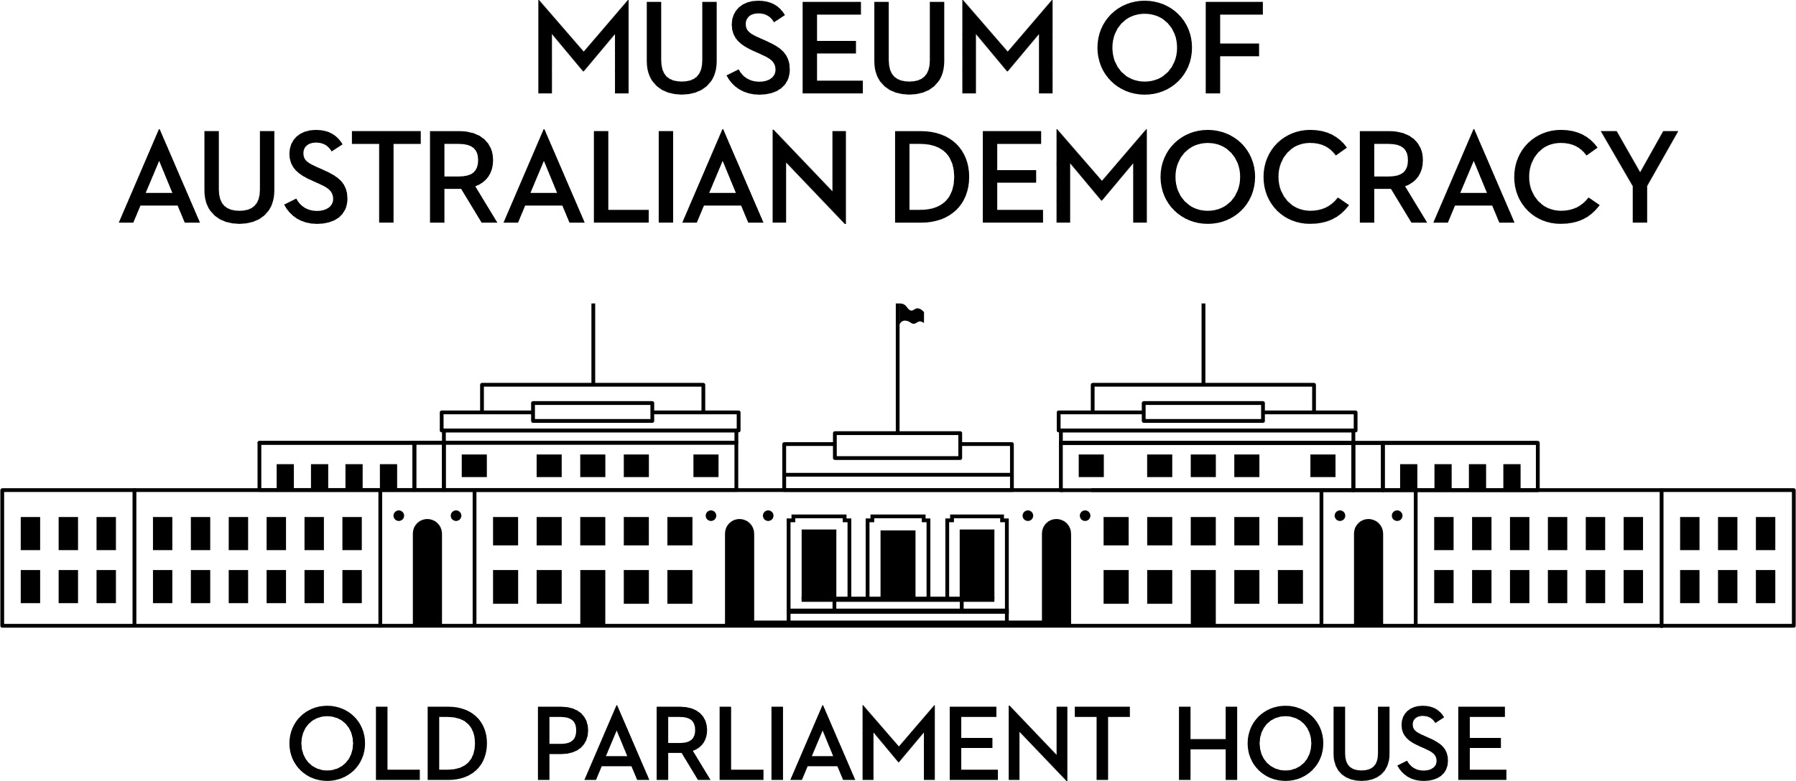

**CANDIDATE PACK**

|  |  |
| --- | --- |
|  | |
| **POSITION DETAILS** | |
| **REFERENCE NO** | NP |
| **TITLE** | Systems Support Officer |
| **CLASSIFICATION** | APS Level 4 |
| **EMPLOYMENT TYPE** | Non-Ongoing |
| **WORKING HOURS** | Full-time |
| **OFFICE ARRANGEMENT** | On-site |
| **SALARY** | $75,385 - $81,775 pa + 15.4% Superannuation |
| **SECTION** | IT |
| **TEAM** | Service Delivery |
| **ELIGIBILITY** | * Australian Citizenship * Security Clearance (after commencement) |
| **CONTACT OFFICER** | Andrew Levison, [Andrew.levison@moadoph.gov.au](mailto:Andrew.levison@moadoph.gov.au) |
| **OPENING DATE** | Friday 15 August 2025 |
| **CLOSING DATE** | Sunday 31 August 2025, 11:59 pm |
| **SPECIAL NOTE** | **This is a non-ongoing opportunity for 18 months.**  This role may be filled using applications and referee reports only.  Suitable candidates may be placed in a merit pool from this selection process and the pool may be used to fill similar ongoing or non-ongoing roles. Non-ongoing vacancies filled from a merit pool may be offered as a specified term.  Applicants may have their application and assessment results shared with other Australian Public Service (APS) agencies looking to fill similar roles. |

**ABOUT US**

The Museum of Australian Democracy (MoAD) at Old Parliament House is located inside a heritage-listed building that was once home to Australia's Parliament (1927 to 1988).

True to our building’s original brief, we provide a ‘people’s place’, where big ideas are explored.

We share the story of Australia's democracy through exhibitions, events and education programs, as well as through our rich online collection of stories, objects and resources.

At MoAD, we celebrate the Australian democratic journey. We seek to provoke thought and inspire conversation by sharing stories and objects that played a part in shaping the nation as it is today.

Careers at MoAD are varied, from human resource officers, exhibition curators, heritage officers and learning facilitators, to digital producers, finance officers and IT specialists. We are a small agency, working in a dynamic environment, sharing our democratic and political history in a heritage-listed building.

MoAD is an inclusive and rewarding workplace that values the contributions of all our staff. We encourage applications from First Nations Australians, people with a disability, culturally and linguistically diverse people and LGBTQIA+ people. We are committed to a safe and supportive workplace which includes flexible working practices.

MoAD employees are engaged under the [*Public Service Act 1999*](https://www.legislation.gov.au/C2004A00538/latest/text) and are subject to the terms and conditions of employment in the [*OPH Enterprise Agreem**ent 2024-2027*](https://moadoph.gov.au/sites/default/files/2024-04/oph-enterprise-agreement-2024-2027.pdf)*.*

**POSITION DETAILS**

Positioned within the IT team, the APS4 Systems Support Officer will support the roll out, continued development, and take-up of various enterprise-wide platforms and software that deliver critical business functions for the agency.  

The role will promote the agencies strategic goals by providing technical support for the museum’s corporate and non-corporate environments and technologies, including a basic UNCLASSIFIED Windows domain. The position will also work with the Systems Training Officer to provide level 1 and 2 support and training for MoAD’s digital systems including SharePoint Online, Teams and Salesforce. They will also champion the agency’s security policies, change management and systems access procedures.

**ROLE RESPONSIBILITIES and DUTIES**

Under the direction of the EL1 Manager IT and guidance of APS6 Systems Administrator the Systems Support Officer will be required to:

* Provide basic level 1 & 2 technical support to staff and perform basic system administration.

* Respond to and manage ICT service requests.

* Assist with the maintenance of MoAD’s ICT systems.

* Prepare and maintain system and process documentation.

* Work with vendors to diagnose and correct problems.

* Work with the agency to facilitate change management across the enterprise platforms.

* Carry out additional administrative duties as required.

**OUR IDEAL CANDIDATE**

You are a natural communicator and enjoy talking to people. You are a natural problem solver and strive for IT excellence through educational and technical approaches.

You understand the value of policies and procedures in an organisation and its role in ensuring a business systems are secure and maintainable against relevant industry best practices while meeting government regulations and requirements.

 You are passionate about technology and systems, ensuring that both are functioning and maintained for effective daily operations and supporting staff requirements.

To be successful for this role you will need to demonstrate:

* Ability to respond to support requests in a timely manner.

* Good time-management skills, with the ability to prioritise tasks and exercise sound judgement and initiative.

* Proactive approach to professional development and learning.

* Ability to work effectively within a small team and to engage positively with stakeholders.

* Ability to effectively follow directions provided by a supervisor and keep supervisors and team members up to date

* Well-developed oral communication skills, with the ability to breakdown and communicate technical issues to non-technical audiences.

**Highly desirable**



* Understanding the importance of, and experience in supporting organization-wide business systems such as Salesforce and Microsoft 365 applications, including SharePoint Online, and Teams.

**YOUR APPLICATION**

Please provide a:

* concise statement of claims of no more than 2 pages. When framing your statement, please ensure you adequately demonstrate your skills, qualifications, experience and capabilities.
* Resume outlining your career history, qualifications and contact details for at least two recent referees (no more than 4 pages).
* coversheet from the [MoAD Website](https://www.moadoph.gov.au/about/careers).

MoAD accommodates requests for reasonable adjustment for people with disabilities to participate in an interview, including offering onsite tours to potential employees before their interviews to gauge any possible access barriers and to comfortably see staff spaces before committing to interview or the job position. Please indicate this in your cover sheet or contact the recruitment officer on 02 6270 8235 or 02 6270 8127.

**ELIGIBILITY**

To be eligible for this position at MoAD, applicants must:

* be an Australian Citizen; and
* have a security clearance or be willing to undertake the process to obtain a baseline clearance (after commencement).
* be willing to provide identity documents and undergo an identity pre-employment check through a Document Verification Service, if you are deemed to be the successful candidate.

**SUBMISSION OF APPLICATION**

Your application should be submitted by the closing date to [applications@moadoph.gov.au](mailto:applications@moadoph.gov.au)

For noting:

* Your application will be automatically acknowledged. If you do not receive an automated receipt, please contact 02 6270 8235 or 02 6270 8127 or email [recruitment@moadoph.gov.au](mailto:recruitment@moadoph.gov.au)
* Applications received after closing will not be accepted unless a prior arrangement has been made with the contact officer