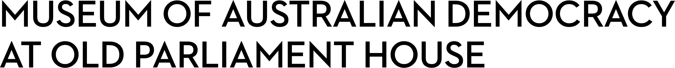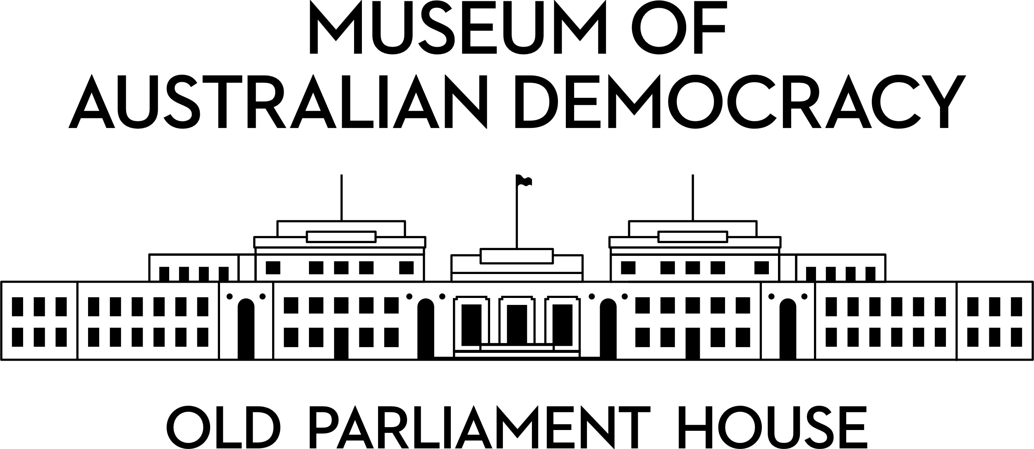

**CANDIDATE PACK**

|  |  |
| --- | --- |
|  | |
| **POSITION DETAILS** | |
| **REFERENCE NO** | 22418 |
| **TITLE** | Digital Content Coordinator |
| **CLASSIFICATION** | APS Level 4 |
| **EMPLOYMENT TYPE** | Non-Ongoing, 12 months |
| **WORKING HOURS** | Full-time |
| **OFFICE ARRANGEMENT** | On-site with work from home considered |
| **SALARY** | $75,385 - $81,775 + 15.4% superannuation |
| **SECTION** | Digital |
| **TEAM** | Digital Projects |
| **ELIGIBILITY** | * Australian Citizenship * Security Clearance (after commencement) |
| **CONTACT OFFICER** | Jayne Regan, [jayne.regan@moadoph.gov.au](mailto:jayne.regan@moadoph.gov.au), (02) 6270 8186 |
| **OPENING DATE** | Friday, 8 August 2025 |
| **CLOSING DATE** | Sunday, 24 August 2025 11:59pm |
| **SPECIAL NOTE** | **This is a non-ongoing opportunity for a period of 12 months, with the possibility of ongoing.**  Suitable candidates may be placed in a merit pool from this selection process and the pool may be used to fill similar ongoing or non-ongoing roles. Non-ongoing vacancies filled from a merit pool may be offered as a specified term.  Applicants may have their application and assessment results shared with other Australian Public Service (APS) agencies looking to fill similar roles. |

**ABOUT US**

The Museum of Australian Democracy (MoAD) at Old Parliament House is located inside a heritage-listed building that was once home to Australia's Parliament (1927 to 1988).

True to our building’s original brief, we provide a ‘people’s place’, where big ideas are explored.

We share the story of Australia's democracy through exhibitions, events and education programs, as well as through our rich online collection of stories, objects and resources.

At MoAD, we celebrate the Australian democratic journey. We seek to provoke thought and inspire conversation by sharing stories and objects that played a part in shaping the nation as it is today.

Careers at MoAD are varied, from human resource officers, exhibition curators, heritage officers and learning facilitators, to digital producers, finance officers and IT specialists. We are a small agency, working in a dynamic environment, sharing our democratic and political history in a heritage-listed building.

MoAD is an inclusive and rewarding workplace that values the contributions of all our staff. We encourage applications from First Nations Australians, people with a disability, culturally and linguistically diverse people and LGBTQIA+ people. We are committed to a safe and supportive workplace which includes flexible working practices.

MoAD employees are engaged under the [*Public Service Act 1999*](https://www.legislation.gov.au/C2004A00538/latest/text) and are subject to the terms and conditions of employment in the [*OPH Enterprise Agreem*](https://moadoph.gov.au/sites/default/files/2024-04/oph-enterprise-agreement-2024-2027.pdf)*ent 2024-2027.*

**POSITION DETAILS**

The Digital team works collaboratively across the Museum to create engaging digital content for the web, social media channels and exhibitions. The successful candidate will contribute to the creation and publication of digital content about our exhibitions, programs, collection and stories of Australian democracy.

This role will respond to content requests from across the Museum and will collaborate with stakeholders to support the development of accessible, inclusive, engaging and accurate content to promote Museum activities. This role will also support the documentation of team procedures and provide general administrative support to the Digital team.

**ROLE RESPONSIBILITIES and DUTIES**

Under the direction of the Digital Projects Manager, the Digital Content Coordinator will be required to:

* Collaborate with teams across the Museum to prepare engaging content for publication on the MoAD website.
* Assist in publishing and editing content on the MoAD website in line with style, user experience and accessibility requirements.
* Research and license photographs and video for use in digital content.
* Identify and assist in testing new website enhancements and features.

* Use analytics tools to gather, interpret and analyse data to report on digital content performance and suggest ways to improve digital content.
* Draft briefs for and liaise with suppliers (e.g. photographers).

* Contribute to the documentation of Digital team procedures and provide general administrative support to the Digital team.

**OUR IDEAL CANDIDATE**

To be successful for this role you will need:

* Well-developed written and verbal communication skills.
* Demonstrated ability to work effectively within a small team.
* Experience working with stakeholders to understand their needs and requirements.
* High attention to detail, particularly when drafting and editing content and managing documentation.
* Demonstrated ability to show initiative, share knowledge and take on constructive feedback.
* The ability to use, or quickly acquire knowledge of, relevant applications including Microsoft 365, content management systems (especially Drupal and Sharepoint), Google Analytics and social media platforms.
* Prior experience creating and publishing audience-focused digital content is highly desirable.

**YOUR APPLICATION**

Please provide a:

* concise statement of claims of no more than 2 pages. When framing your statement, please ensure you adequately demonstrate your skills, qualifications, experience and capabilities.
* Resume outlining your career history, qualifications and contact details for at least two recent referees (no more than 4 pages).
* coversheet from the [MoAD Website](https://www.moadoph.gov.au/about/careers).

MoAD accommodates requests for reasonable adjustment for people with disabilities to participate in an interview, including offering onsite tours to potential employees before their interviews to gauge any possible access barriers and to comfortably see staff spaces before committing to interview or the job position. Please indicate this in your cover sheet or contact the recruitment officer on 02 6270 8235 or 02 6270 8127.

**ELIGIBILITY**

To be eligible for this position at MoAD, applicants must:

* be an Australian Citizen; and
* have a security clearance or be willing to undertake the process to obtain a baseline clearance (after commencement).
* be willing to provide identity documents and undergo an identity pre-employment check through a Document Verification Service, if you are deemed to be the successful candidate.

**SUBMISSION OF APPLICATION**

Your application should be submitted by the closing date to [applications@moadoph.gov.au](mailto:applications@moadoph.gov.au)

For noting:

* Your application will be automatically acknowledged. If you do not receive an automated receipt, please contact 02 6270 8235 or 02 6270 8127 or email [recruitment@moadoph.gov.au](mailto:recruitment@moadoph.gov.au)
* Applications received after closing will not be accepted unless a prior arrangement has been made with the contact officer